Delta City
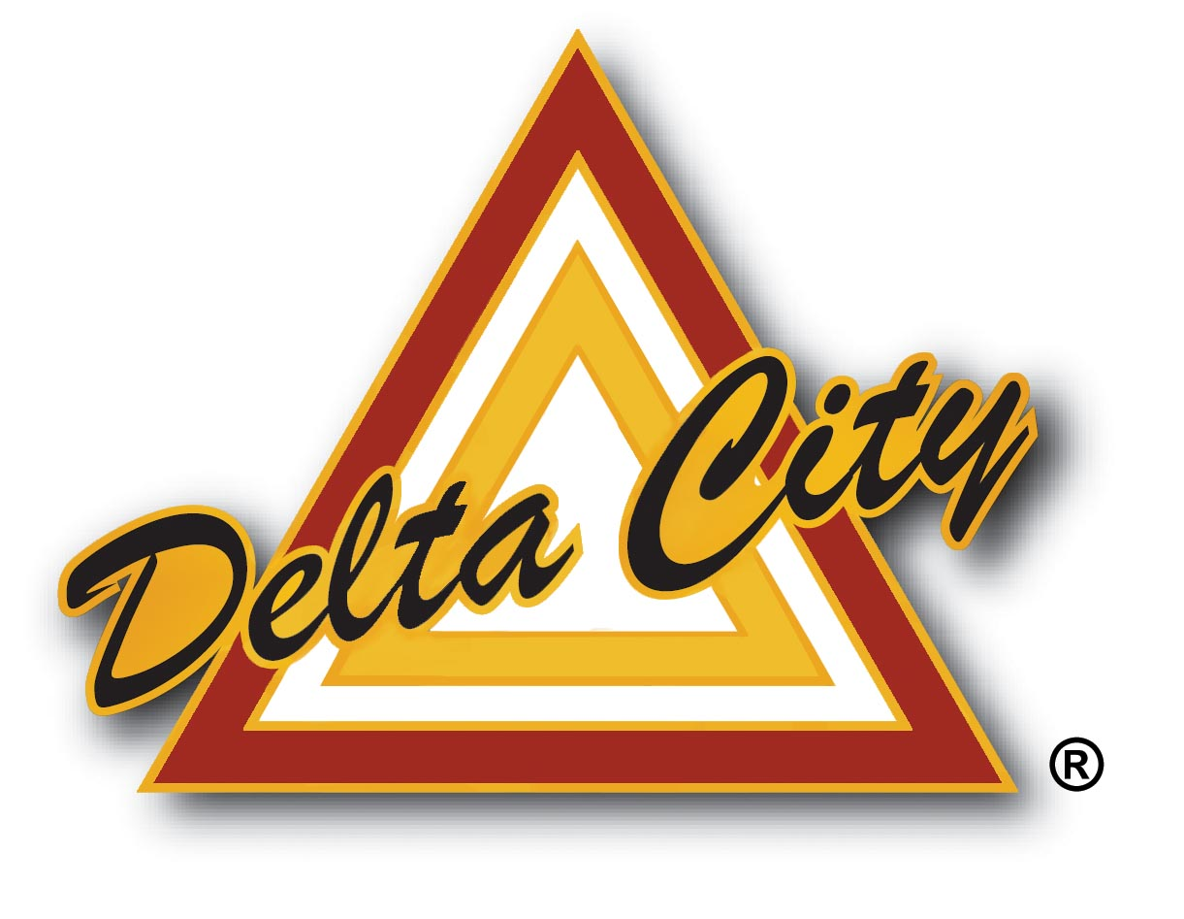
Job Description

Job Title: Public Works Operator I Job Code: 213
Division: Operations Effective Date:
Department: Public Works Last Revised:

GENERAL PURPOSE

Acting in a “restricted” capacity, performs a variety of entry level skilled duties related to the construction, installation, maintenance and repair of city public works service systems including streets, water distribution, waste water collection, waste water processing and city environment maintenance.

SUPERVISION RECEIVED

Works under the general supervision of the Field Supervisor, Assistant Public Works Director or the Public Works Director.

SUPERVISION EXERCISED

None.

essential functions

Water: Operates backhoe and trenching equipment; performs installation or repair of water service connections, water lines and meters, repairs or replaces plugged water meters; repairs water mains; cleans and maintains storage tanks, springs and wells; thaws water pipes; repairs or replaces fire hydrants and water regulators; monitors water meters and pressure regulators; radio reads and repairs meters.

Operates a variety of hand tools and small power equipment such as jack hammers, roller, compressors, packing machine, threading machine, tapping machine and tampers; installs new water lines using pipe threader, tapping machine, welder, pipe cutting saw, pipe and cable locater; repairs old water lines; tears out and repairs curb, gutter and street in locating and uncovering broken lines; builds meter boxes; builds extensions to raise or lower existing boxes as needed; cleans tools and equipment; draws water samples.

Sewer: Performs sewer collection system installation, maintenance, and repairs; operates a variety of hand or power equipment, including tapping machine, jack hammer, compactor, rodding machine, etc.; Installs new sewer mains; taps mains to make service connections; repairs leaks in sewer system(s); operates sewer truck/JetVac; maintains and cleans city sewer collection system main lines; inspects manholes and sewer lines to detect leaks or malfunctions; bolts leak-proof collars to mains to stop leaks; seals joints with cementing compound; opens clogged sewer lines using various pipe cleaning equipment.

Streets: Operates specialized heavy equipment such as single & tandem axle dump trucks, road graders, front-end loaders, backhoe, bucket trucks, roller, snow plow, sanders, excavator, street sweeper, and other similar equipment in the construction, maintenance and repair of various public works projects and sites; performs cement work on flat surfaces, curbs, and gutter; grouts surfaces and joints.

Transports and deposits various construction materials such as sand, salt, gravel, dirt, asphalt, etc.; performs hot and cold mix patching, storm drain cleaning, repair and construction, snow and ice control, debris collection, etc.; participates in work site safety procedures; sets up barricades, safety signs and signal equipment; checks and services assigned equipment; performs routine maintenance and emergency repairs; reports mechanical problems to the shop for repair; paints lane stripes and parking stripes.

Participates in tree trimming projects as needed to ensure safe travel and operations in the public right-of-way for city workers and the general public.

Vehicle Preventative Maintenance: Performs routine maintenance functions as needed to ensure safe and efficient vehicle and equipment operations; follows general preventative maintenance schedules related to fluid levels, air pressures, electrical functions, hydraulics, etc.; may perform general welding and part fabrication.

Facilities Maintenance: Participates in the construction, maintenance and repair of city structures and facilities including framing, roofing, plumbing, electrical, HVAC, etc.

Performs related duties as required.

Public Works Operator I, page 2
MINIMUM QUALIFICATIONS

1. Education and Experience:

A. Graduation from high school;
AND
B. One year of experience in construction, maintenance or repair of public works systems;
OR
C. An equivalent combination of education and experience.

2. Knowledge, Skills, and Abilities:

Some knowledge of operating basic manual and power tools; the standard practices, methods, materials and tools necessary for pipe line construction and repair activities; pipe fitting procedures including water and sewer; the occupational hazards and safety precautions of trench work construction and pipeline maintenance work; hazards common to heavy equipment operation; safety standards related to street construction and maintenance; material and methods of constructing roads, drain systems etc.; water supply and distribution systems; hazards associated with water treatment chemicals; wastewater and airborne pathogens; state or federal regulations governing installation and maintenance of water and sewer systems; water quality laws; weed spraying regulations and standards; interpersonal communication skills.

Some skill operating heavy equipment and common power tools including road grader, dump truck, loader, backhoe, track hoe, snow plow, skid-steer sander, trailer, roller, asphalt equipment, sewer jet, trench boxes, spray trucks sewer camera, vactors, torches, welders, drills rodders, generators, SCADA system, etc.

Ability to operate heavy equipment of various kinds under varying conditions; perform heavy physical labor; develop and maintain effective working relationships with co-workers, local agencies and the general public; communicate effectively, both verbally and in writing; work from blueprints; tolerate weather extremes in the work environment; ability to perform basic mathematical computations in reading and using various meters, gauges and related devices.

3. Special Qualifications:

Must possess a valid Utah Commercial Driver’s license (CDL-B). May be required to be a certified flagger. Must be able to lift 50-75 pounds. Must be willing to work on-call duty and 24-hour standby. Must pass a pre-employment background check and drug screen.

4. Work Environment:

Tasks require variety of physical activities, involving varying degrees of muscular strain, related to walking, standing, stooping, sitting, reaching and lifting. Essential functions require talking, hearing and seeing. Common eye, hand, finger dexterity is essential to daily functions. Mental application utilizes memory for details, verbal instructions, emotional stability, discriminating thinking and creative problem solving. Regular local travel required in normal course of job performance. Daily exposure to hazardous conditions such as: working on high ladders and in manholes; daily potential for hazardous exposure to methane, hydrogen sulfide and chlorine gases; daily potential for hazardous exposure to oxygen deficient atmosphere; daily exposure to seasonal changes and weather extremes; daily potential for hazardous exposure to electrical shock, industrial wastes and raw sewage (containing pathogens such as typhoid, paratyphoid, dysentery, polio, tetanus, etc.); daily exposure to moving parts and equipment such as pumps, motors, heavy equipment, etc.; daily exposure to stressful environmental conditions such as dust, fumes, dampness, cold, heat and noise.

*****
Disclaimer: The above statements describe the general nature, level, and type of work performed by the incumbent(s) assigned to this classification. They are not intended to be an exhaustive list of all responsibilities, demands, and skills required of personnel so classified. Job descriptions are not intended to and do not imply or create any employment, compensation, or contract rights to any person or persons. Management reserves the right to add, delete, or modify any and/or all provisions of this description at any time as needed without notice. This job description supersedes earlier versions.

I have reviewed this position description that I currently hold with Delta City. Signature ________________________________________________

Date Signed ______________________________________________

