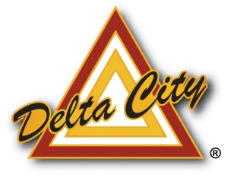
Delta City
76 N 200 W
Delta, UT 84624
435-864-2759
www.delta.utah.gov

2025 NOTICE OF CITY COUNCIL VACANCY
(UCA 20A-1-510)

Delta City announces a vacancy in the office of City Council created by the resignation of Council Member KC Bogue. This Council seat will be for the term of January 5, 2026 – January 2028.

The City Council will fill this vacancy at a special meeting to be held on the following date:

Wednesday, January 7, 2026, at 6:00 pm
Delta City Municipal Complex, 76 N 200 W, Delta, Utah 84624

Any qualified person interested in being considered for appointment to the position of City Council may submit their application and conflict of interest disclosure statement and $25.00 filing fee to Sherri Westbrook, City Recorder. Applications must be accepted in person, during regular business hours (Monday - Thursday 7:00 am - 6:00 pm), no later than Monday, January 5, 2026, at 5:00 pm. The application and conflict of interest disclosure statement can be found on the City’s website (www.delta.utah.gov) or at the city office building located at 76 N 200 W, Delta, UT.
For additional information please contact Sherri Westbrook, Delta City Recorder, at (435) 864-2759.

Dated the 15th day of December 2025
Sherri Westbrook
City Recorder

